URL: <http://www.iihani.com/>

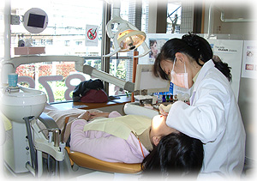 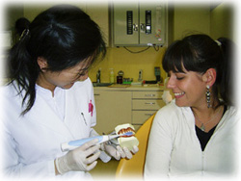

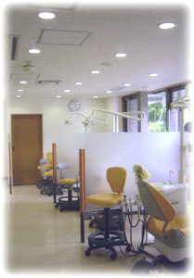 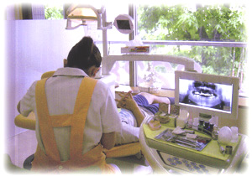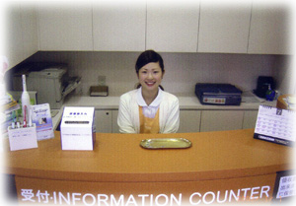 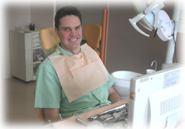

Nishieifuku dental clinic is the proud to be the first choice among expatriates living in Tokyo.  
By redefining the benchmark for dental services available until now in Japan. We have the latest dental units incorporating the (no back flow system) combined with our highest guarantee of complete sterilization and disinfection of all equipment. he treatment room is extremely spacious with large windows, offering an ambient relaxing western image combined with soothing BGM and a friendly English speaking dentist.

**Dental procedures:**

1. Crown and Denture construction
2. Bridge construction
3. Cavity and Root canal treatment
4. Bone regeneration
5. Cleaning & Whitening
6. Gingivitis treatment
7. Aesthetic dentistry

**Doctor’s credentials:**

Dr.Freeman is fluent in the English Language having studied and lived in Australia.  
This photo was taken at the Asian Ankylos Symposium party.  
Professor.Dr.G.Nentwig of Frankfurt University in Germany is sitting on my left. Professor Nentwig was the inventor of the Ankylos Implant system.  
This system is now one of the most technologically advanced Implants used throughout the world today.

 1970 Born in Tokyo Japan .

1989 Graduated in violin studies from Komabatodaimae Art High School.

1995 Graduated from Tsurumi University Scool of Dentistry(D.D.S.) .

1996 Certified in ITI implantlogy technique.

1998 Promoted to vice head dentist of Takanawa dental network.

1999 Presenter of the U.S.Army Tri-Service Dental Society of Japan Conference.

1999 Promoted to the head dentist of Takanawa dental network.

2001 Studied dentistry in Australia.  
Including the latest Emdogain and Aesthetic treatments.

2002 President and Head dentist of Nishieifuku dental clinic.

**Contact us:**

Address: 4-19-10 2F Eifuku Suginami-ku, Tokyo Japan  
Phone: 03-5378-2228  
Fax: 03-6909-6168